Activity 3.1
Data Flow Diagram
Course Code: CPE025 | Program:
Course Title: Software Design | Date Performed:
Section: | Date Submitted:
Team No: | Instructor:
Team Leader:
Members:

1. Objective:
This activity aims to develop a dataflow diagram of the system.
2. Intended Learning Outcomes (ILOs):
The students should be able to:
2.1 Construct a context dataflow diagram
2.2 Construct a dataflow level 0 diagram

3. Discussion
The Data Flow Diagram (DFD) is a graphical representation of the flow of data through an information system. It represents the process in the information system in terms of the data. It visualizes how the system operates, what the system accomplishes and how it will be implemented, when it is refined with further specification. It can be used by the systems analysts to model the organization and design the proposed system
There are two types of DFDs, both of which support a top-down approach to systems analysis, whereby analysts begin by developing a general understanding of the system and gradually break components out into greater detail:
- Logical data flow diagrams - are implementation-independent and describe the system, rather than how activities are accomplished.
- Physical data flow diagrams - are implementation-dependent and describe the actual entities (devices, department, people, etc.) involved in the current system.

Data Flow Diagram Symbols
Name | Symbol | Meaning | Example
Entity |  | An entity. A source of data or a destination for data. | 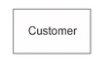
Process |  | A process or task that is performed by the system. | 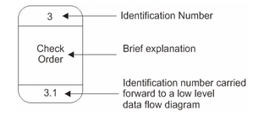
Data Store | 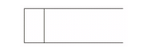 | A data store, a place where data is held between processes. | 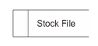
Data Flow | 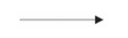 | A data flow. | 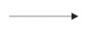

4. Resources:
Personal Computer
Microsoft Word / Microsoft Visio
5. Activities:
- Make a list of business activities and use it to determine various
  - External entities
  - Data flows
  - Processes
  - Data stores
- Create a context diagram that shows external entities and data flow to and from the system. Do not show any detailed processes or data stores.
- Draw Diagram 0, the next level. Show processes, but keep them general. Show data stores at this level.
- Create a child diagram for each of the processes in Diagram 0.
- Check for errors and make sure the labels you assign to each process and data flow are meaningful.
- Develop a physical data flow diagram from the logical data flow diagram. Distinguish between manual and automated processes,
- Describe actual files and reports by name, and add controls to indicate when processes are complete or errors occur.
- Partition the physical data flow diagram by separating or grouping parts of the diagram in order to facilitate programming and implementation.
6. Deliverables:
- Context Data Flow Diagram
- Level 0 Data Flow Diagram
- Logical and Physical Data Flow Diagram

7. Assessment (Rubric for Laboratory Performance):

